Name

Mathematics Extension 1 Year 12
Properties of Functions, Relations and Graphs

Book 1 |  | Version: 261019  Feedback:  https://MrDingMaths.com
Contents
Syllabus Content 2
Learning Intention 3

Syllabus Content
MAV-11-02 uses functions and relations to model, analyse and solve problems
Properties of functions, relations and graphs
- Extend the definitions of domain and range to relations
- Recognise domains and ranges of functions and relations given in interval notation, as inequalities and as worded descriptions
- Determine and describe the domain and range of functions and relations, using interval notation, inequalities or worded descriptions
- Define a function to be even if its graph is unchanged under reflection in the $y$-axis, and odd if its graph is unchanged under rotation of $180°$ about the origin
- Develop and use the tests that a function $f(x)$ is odd if $f\left(-x\right)=-f(x)$ and a function $f(x)$ is even if $f\left(-x\right)=f(x)$
- Solve problems involving even and odd functions
- Use the composite function $f\left(g\left(x\right)\right)$, where the output of $g\left(x\right)$ becomes the input of $f\left(x\right)$
- Determine the equations of composite functions

Odd and Even Functions

- Odd and Even Function
Functions can show two types of symmetry, helping us solve problems involving their graphs.
Odd Function  180° rotational symmetry about the origin  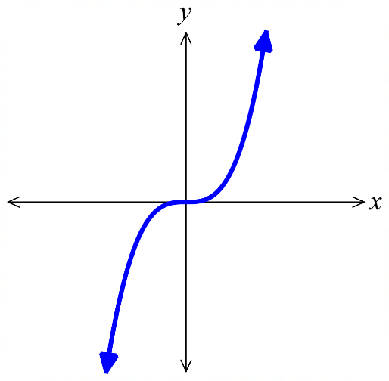 | Even Function  Line symmetry across $y$-axis  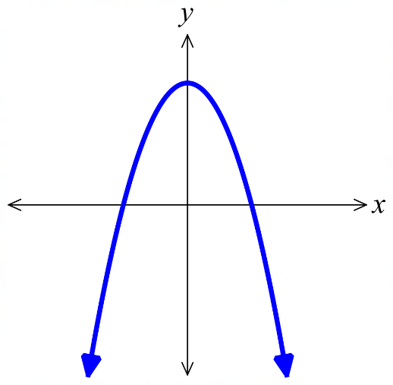

- Classify graphs of functions as even, odd, neither
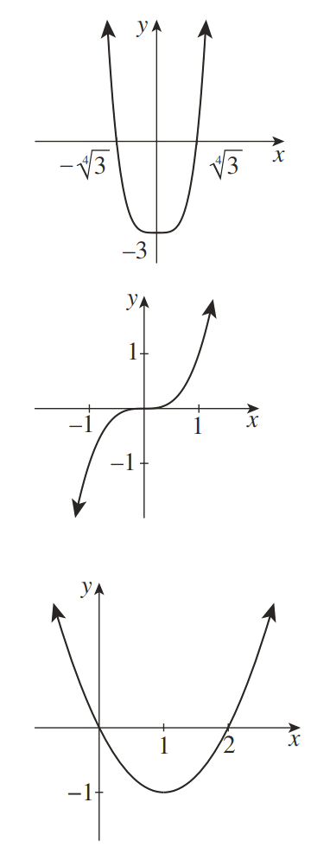  - Even  - Odd  - Neither | 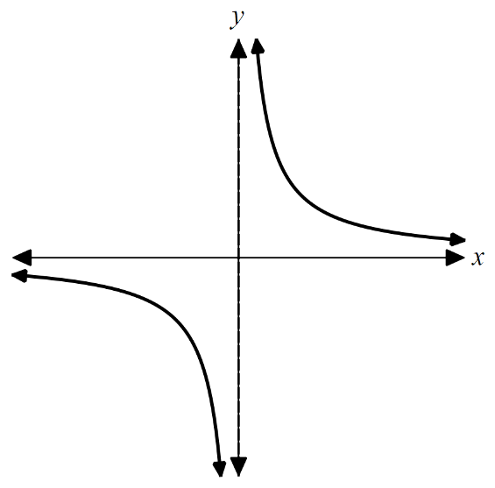  - Even  - Odd  - Neither | - Even  - Odd  - Neither
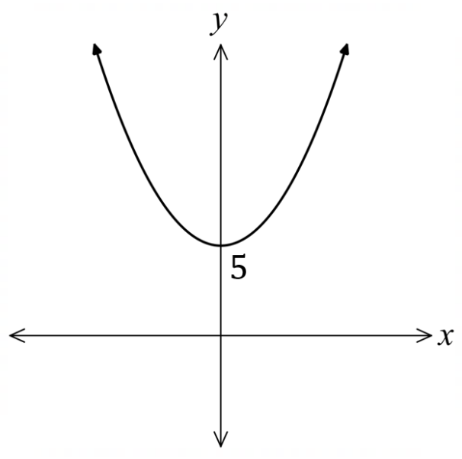  - Even  - Odd  - Neither | 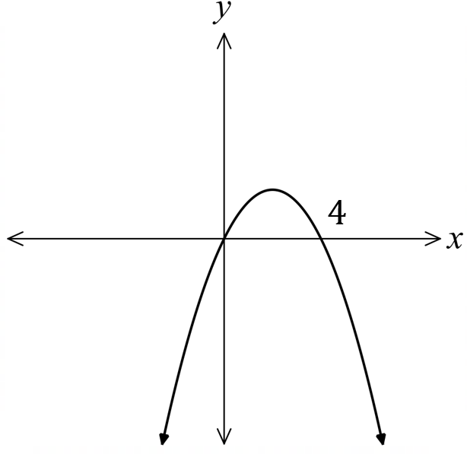  - Even  - Odd  - Neither | 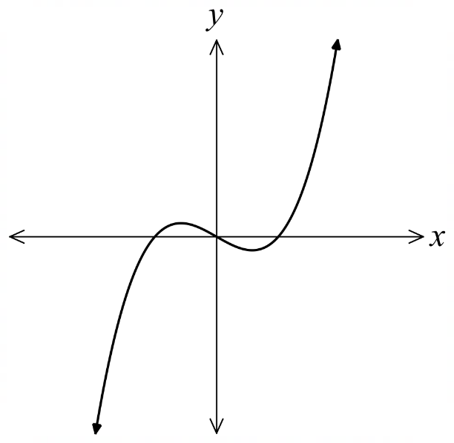  - Even  - Odd  - Neither

Foundation
- Classify these functions as even, odd, or neither.
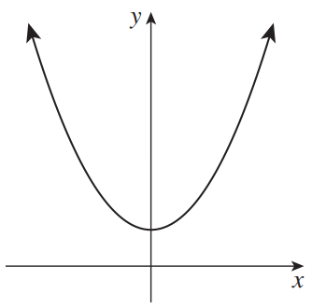  - Even  - Odd  - Neither  even | 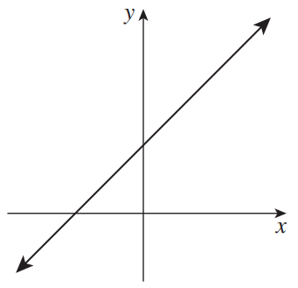  - Even  - Odd  - Neither  neither | 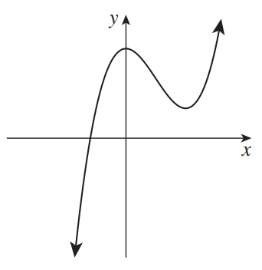  - Even  - Odd  - Neither  neither
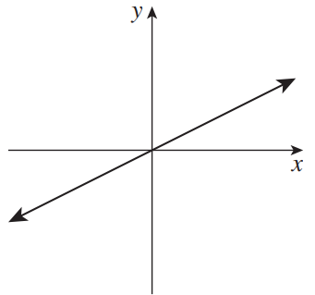  - Even  - Odd  - Neither  odd | 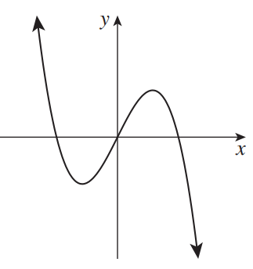  - Even  - Odd  - Neither  odd | 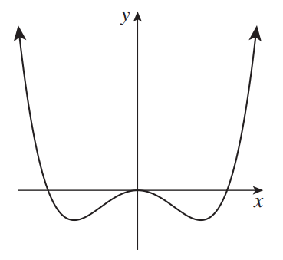  - Even  - Odd  - Neither  even
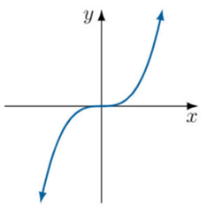  - Even  - Odd  - Neither  odd | 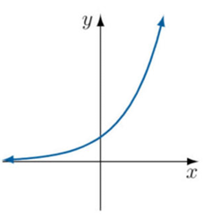  - Even  - Odd  - Neither  neither | 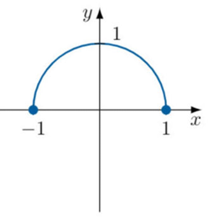  - Even  - Odd  - Neither  even

- Sketch the second half of these graphs so they are even.
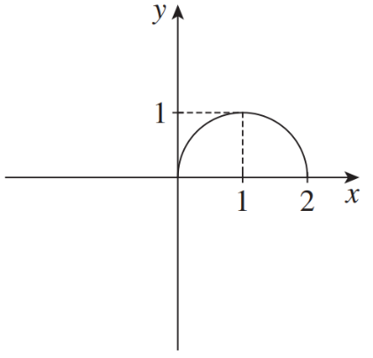 | 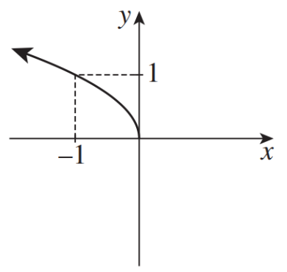 | 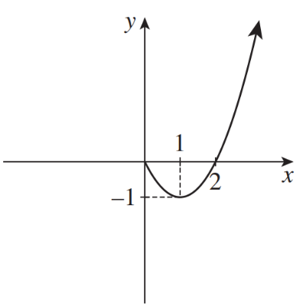
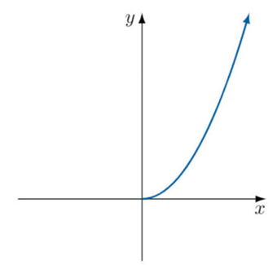 | 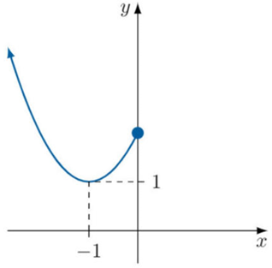 | 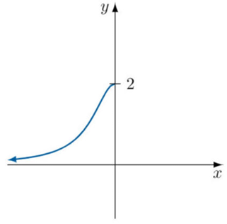

- Sketch the second half of these graphs so they are odd.
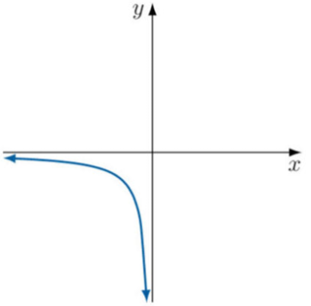 | 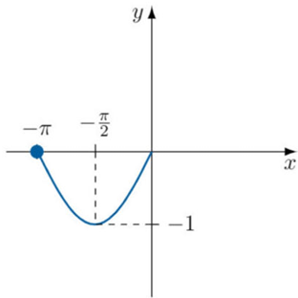 | 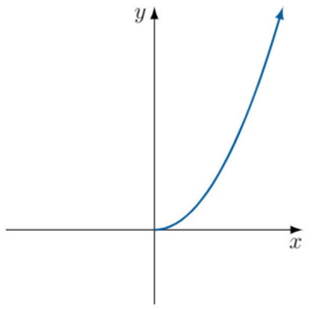

Testing Odd and Even Algebraically

- Review
- Find $f\left(-x\right)$ and $-f\left(x\right)$ for each of these functions.
- $f\left(x\right)=3x-2$ | - $f\left(x\right)=x^{2}-4$ | - $f\left(x\right)=x^{2}-2x$
- $f\left(x\right)=x^{3}+x$ | - $f\left(x\right)=9-x^{2}$ | - $f\left(x\right)=x^{2}+5x+6$
- $f\left(x\right)=$ $\frac{x+3}{x}$ | - $f\left(x\right)=$ $\frac{x^{3}}{x^{4}-x^{2}}$ | - $f\left(x\right)=$ $\frac{x-3}{x+3}$

- Testing Odd and Even Algebraically
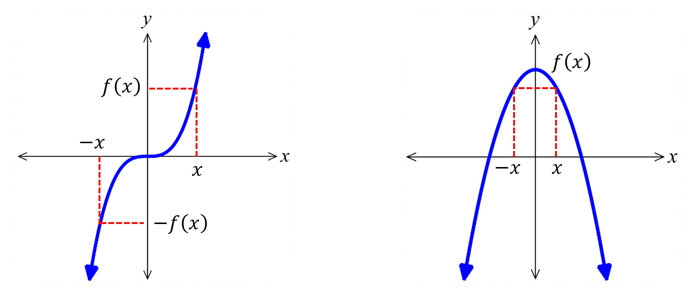  Odd Function  $$f\left(-x\right)=-f(x)$$ | Even Function  $$f\left(-x\right)=-f\left(x\right)$$
- Substitute in $f\left(-x\right)$.
- Simplify as much as possible.
- Even if $f\left(-x\right)=f\left(x\right)$.
Odd if $f\left(-x\right)=-f\left(x\right)$.
Neither if $f\left(-x\right)$ does not match $f\left(x\right)$ nor $-f\left(x\right)$.

- Example Classify equations of functions as odd, even, or neither algebraically
$f\left(x\right)=x^{4}-3$  1. $f\left(-x\right)={\left(-x\right)}^{4}-3$  2. $=x^{4}-3$  3. $=f\left(x\right)$  Even function. | $f\left(x\right)=x^{3}-x$  1. $f\left(-x\right)={\left(-x\right)}^{3}-\left(-x\right)$  2. $=-x^{3}+x$  3. $=-f\left(x\right)$  Odd function. | $f\left(x\right)=x^{2}-2x$  1. $f\left(-x\right)={\left(-x\right)}^{2}-2(-x)$  2. $=x^{2}+2x$  3. Neither odd nor even.

- Guided Practice
Determine whether these functions are odd, even, or neither.
- $f\left(x\right)=x^{2}+5$  even | - $f\left(x\right)=x\left(x-4\right)$  neither | - $f\left(x\right)=x-x^{3}$  odd
- $f\left(x\right)=$ $\frac{x^{2}+1}{x}$  odd | - $f\left(x\right)=$ $\frac{x^{3}}{x^{3}-x}$  even | - $f\left(x\right)=$ $\frac{x-3}{x+3}$  neither

Foundation
- Determine whether these functions are even, odd, or neither.
- $f\left(x\right)=2x$  $f\left(-x\right)=$  odd | - $f\left(x\right)=x^{2}+1$  even | - $f\left(x\right)=x^{2}+x$  neither
- $f\left(x\right)=x^{3}$  odd | - $f\left(x\right)=x-x^{3}$  odd | - $f\left(x\right)=$ $\frac{1}{x}$  odd
- $f\left(x\right)=x^{4}-2x^{2}+1$  even | - $g\left(x\right)=x^{3}-3x$  odd | - $h\left(x\right)=x^{3}+3x^{2}-2$  neither
- $f\left(x\right)=x^{2}-9$  even | - $f\left(x\right)=x^{3}-25x$  odd | - $f\left(x\right)=x^{3}+5x^{2}$  neither
- $f\left(x\right)=2^{x}$  neither | - $f\left(x\right)=\sqrt{3-x^{2}}$  even | - $f\left(x\right)=$ $\frac{1}{x^{2}+1}$  even
- $f\left(x\right)=$ $\frac{4x}{x^{2}+4}$  odd | - $f\left(x\right)=$ $x\sqrt{9-x^{2}}$  odd | - $f\left(x\right)=$ $\frac{x}{x^{2}-4}$  odd

Development
- Decide whether these functions are odd or even.
Check your answer by sketching the curve on DESMOS.
- $y=$ $\frac{x^{3}}{x^{4}-x^{2}}$  odd | - $y=$ $\frac{1}{x^{3}-1}$  neither | - $y=$ $\frac{3}{x^{2}-4}$  even
- $y=$ $\frac{x-3}{x+3}$  neither | - $y=$ $\frac{x^{3}}{x^{5}-x^{2}}$  neither | - $y=$ ${\left(x-2\right)}^{2}$  neither
- $f\left(x\right)=3^{x}-3^{-x}$  odd | - $f\left(x\right)=3^{x}+3^{-x}$  even | - $f\left(x\right)=3^{x}+x^{3}$  neither

- For what positive integer values of $n$ is the function $f\left(x\right)=kx^{n}$
- Even?  even values, $n=2, 4, 6, 8,…$ | - Odd?  odd values, $n=1, 3, 5, 7…$

- HSC Advanced Sample Question Band 4
Determine whether $f\left(x\right)=2x^{3}-5x$ is even, odd, or neither. Show all working.

odd

Mastery
- 2016 HSC Advanced Band 5
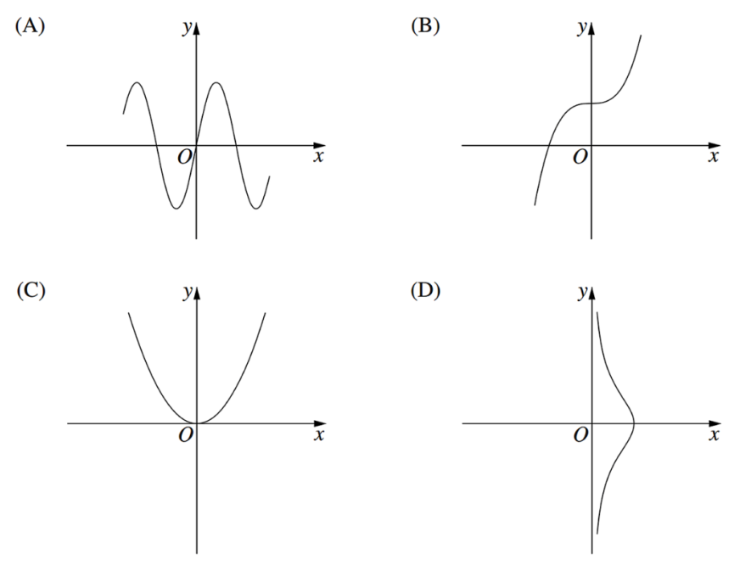
Which diagram shows the graph of an odd function?

A
- 2023 HSC Advanced Band 6
Let $f\left(x\right)$ be any function with domain all real numbers.
Which of the following is an even function, regardless of the choice of $f\left(x\right)$?
(Hint: let $f\left(x\right)$ be a function that is neither, e.g. $f\left(x\right)=x+2$)
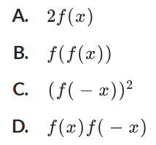

D
- Show that $f\left(x\right)=$ $\frac{2^{2x}+1}{2^{x}}$ is even.

Composite Functions

- Composite Functions
A composite function is where the output of one function is inputted into another function.
We can consider any function that involves two or more operations as a composite function.
In $f\left(g\left(x\right)\right)$, $g\left(x\right)$ is the inner function (evaluated first).
$f\left(x\right)$ is the outer function (evaluated last).

We can write composite functions with notation $f\left(g\left(x\right)\right)$, $fg\left(x\right), f∘g$.
We read $f\left(g\left(x\right)\right)$ as ‘$f$ of $g$’

- Investigation Composite functions
Consider $f\left(x\right)=x^{2}$ and $g\left(x\right)=x+5$

Find $g\left(3\right)$ ……………

Insert the output of $g\left(3\right)$ back into $g\left(x\right)$.
We write this as …………, and the result is: ……………

Now insert the output of $g\left(3\right)$ back into $f\left(x\right)$.
We write this as …………, and the result is: ……………

Let’s do the general case; what would be the result if we insert the output of $g\left(x\right)$ into $f\left(x\right)$?

$f\left(g\left(x\right)\right)=$

Check this works for $f\left(g\left(3\right)\right)$

- Example Determine the equation of a composite function
Given $f\left(x\right)=2x+5$ and $g\left(x\right)=3-4x$, find the simplified expression for $f\left(g\left(x\right)\right)$.
$$f\left(g\left(x\right)\right)=f\left(3-4x\right) \\ =2\left(3-4x\right)+5 \\ =6-8x+5 \\ =11-8x$$

- Guided Practice
- $\text{Given }f\left(x\right)=4x-1 \text{and} g(x)=2x+7$, find $f\left(g\left(x\right)\right)$.

$$8x+27$$
- $\text{Given }f\left(x\right)=5-2x \text{and} g(x)=x^{2}+3\text{, determine} f\left(g\left(x\right)\right)$ and $g\left(f\left(x\right)\right)$.

$$f\left(g\left(x\right)\right)=-2x^{2}-1$$
$$g\left(f\left(x\right)\right)=4x^{2}-20x+28$$
- $\text{Given }f\left(x\right)=x^{2}-25$ and $g\left(x\right)=x+4$
Solve $fg\left(x+1\right)=gf\left(x\right)$

$$x=-2.1$$

- Key Ideas
- A composite function involves using the …………… of the inner function as the ………… to the outer function.

Foundation
- $f\left(x\right)=x+2$.
Find the values of:
- $f\left(f\left(0\right)\right)$  4 | - $f\left(f\left(3\right)\right)$  7 | - $f\left(f\left(-1\right)\right)$  3 | - $f\left(f\left(-8\right)\right)$  $$-4$$
  - Find an expression for $f\left(f\left(x\right)\right)$

$$x+4$$
  - Check your answers for a – d, how do they relate to your expression for $f\left(f\left(x\right)\right)$?

The composite function is to add 4 to the value of $x$, which reflect the answers to part a – d.
  - Find a value of $x$ where $f\left(f\left(x\right)\right)=0$.

$$x=-4$$
- $f\left(x\right)=2x$
Find the values of:
- $f\left(f\left(0\right)\right)$  0 | - $f\left(f\left(7\right)\right)$  28 | - $f\left(f\left(-3\right)\right)$  $$-12$$ | - $f\left(f\left(-11\right)\right)$  $$-44$$
  - Find an expression for $f\left(f\left(x\right)\right)$

$$4x$$
  - Check your answers for a – d, how do they relate to your expression for $f\left(f\left(x\right)\right)$?

The composite function is to multiply the value of $x$ by 4, which reflect the answers to parts a – d.
  - Find a value of $x$ where $f\left(f\left(x\right)\right)=32$.

$$x=8$$

- $g\left(x\right)=2-x$. Show that $g\left(g\left(x\right)\right)=x$.

$$g\left(x\right)=2-x$$
$$g\left(2-x\right)=2-\left(2-x\right)$$
$$∴g\left(2-x\right)=x$$
- $h\left(x\right)=3x-5$. Find an expression for $h\left(h\left(x\right)\right)$.

$$9x-20$$

- Let $f\left(x\right)=3x+4$ and $g\left(x\right)=3-2x$.
- Find $f\left(g\left(2\right)\right)$  1 | - Find $g\left(f\left(2\right)\right)$  $$-17$$
- Show that $f\left(g\left(x\right)\right)=-6x+13$  $f\left(x\right)=3x+4$  $f\left(g\left(x\right)\right)=f\left(3-2x\right)$  $=3\left(3-2x\right)+4$  $=-6x+13$ | - Show that $g\left(f\left(x\right)\right)=-6x-5$  $g\left(x\right)=3-2x$  $$g\left(f\left(x\right)\right)=g(3x+4)$$  $=3-2\left(3x+4\right)$  $=-6x-5$

- $f\left(x\right)=x+1$ and $g\left(x\right)=2x-3$
Find the values of:
- $f\left(g\left(7\right)\right)$  12 | - $g\left(f\left(7\right)\right)$  13 | - $f\left(f\left(7\right)\right)$  9 | - $g\left(g\left(7\right)\right)$  19
Find expressions for
- $f\left(g\left(x\right)\right)$  $$2x-2$$ | - $g\left(f\left(x\right)\right)$  $$2x-1$$ | - $f\left(f\left(x\right)\right)$  $$x+2$$ | - $g\left(g\left(x\right)\right)$  $$4x-9$$

Development
- $\text{Given }f(x)=2x+7 \text{and} g(x)=5x-3\text{, find:}$
- $f(g(x))$  $$10x+1$$ | - $g(f(x))$  $$10x+32$$
- $f(f(x))$  $$4x+21$$ | - $g(g(x))$  $$25x-18$$

- $f\left(x\right)=\sqrt{x}$ and $g\left(x\right)=x+4$
- Find $f\left(g\left(x\right)\right)$  $$\sqrt{x+4}$$ | - Find $g\left(f\left(x\right)\right)$  $$\sqrt{x}+4$$
- Find $g\left(g\left(x\right)\right)$  $$x+8$$ | - What composite function would produce $\sqrt{x+8}$?  $$f\left(g\left(g\left(x\right)\right)\right)$$

- $\text{Given }p(x)=x^{2}-4 \text{and} q(x)=2x+3\text{, simplify}$:
- $p(q(x))$  $$4x^{2}+12x+5$$ | - $q(p(x))$  $$2x^{2}-5$$
- $p(p(x))$  $$x^{4}-8x^{2}+12$$ | - $q(q(x))$  $$4x+9$$

- $\text{Given }h(x)=\frac{2}{x+3} \text{and} m(x)=4x-1\text{, find:}$
- $h(m(x))$  $$\frac{1}{2x+1}$$ | - $m(h(x))$  $$\frac{5-x}{x+3}$$ | - $h(h(x))$  $$\frac{2x+6}{3x+11}$$

- Find $f\left(g\left(x\right)\right)$ and $g\left(f\left(x\right)\right)$ for each of these function pairs.
- $f\left(x\right)=x-2$, $g\left(x\right)=2x+5$  $f\left(g\left(x\right)\right)$  $$2x+3$$  $g\left(f\left(x\right)\right)$  $$2x+1$$ | - $f\left(x\right)=2x$, $g\left(x\right)=3x$  $f\left(g\left(x\right)\right)$  $$6x$$  $g\left(f\left(x\right)\right)$  $$6x$$
- $f\left(x\right)=x^{2}$, $g\left(x\right)=x^{3}$  $f\left(g\left(x\right)\right)$  $$x^{6}$$  $g\left(f\left(x\right)\right)$  $$x^{6}$$ | - $f\left(x\right)=$ $\frac{1}{x}$, $g\left(x\right)=\sqrt{x}$  $f\left(g\left(x\right)\right)$  $$\frac{1}{\sqrt{x}}$$  $g\left(f\left(x\right)\right)$  $$\frac{1}{\sqrt{x}}$$

- $f\left(x\right)=$ $\frac{x}{x+1}$, find $f\left(f\left(x\right)\right)$.

$$\frac{x}{2x+1}$$
- HSC Sample Question Band 4
Given $f\left(2\right)=5, f\left(3\right)=4, g\left(2\right)=5, g\left(3\right)=2,g\left(4\right)=1.$
What is the value of $f\left(g\left(3\right)\right)$?

$$f\left(g\left(3\right)\right)=f\left(2\right)=5$$

- HSC Sample Question Band 4
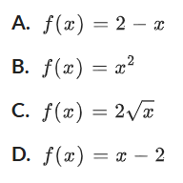
Which of these functions satisfies $f\left(f\left(x\right)\right)=x$?

A
- HSC Sample Question Band 4
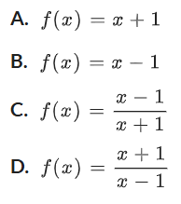
Which of these functions satisfies $f\left(f\left(x\right)\right)=x$?

D

- Consider the graphs of $f\left(x\right)$ and $g\left(x\right)$ below.
  - Evaluate $g\left(3\right)$.
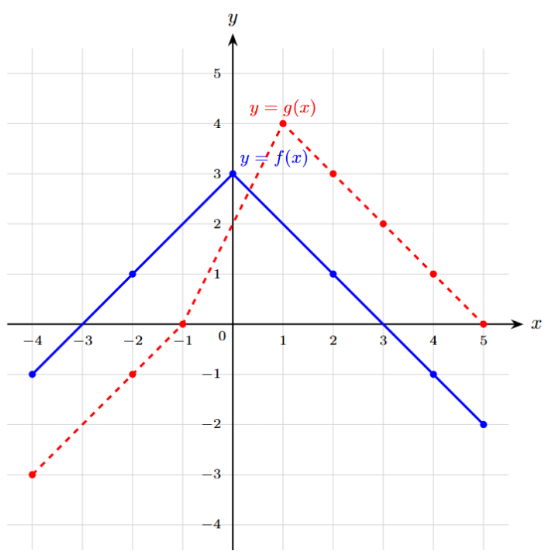
2
  - Hence evaluate $f\left(g\left(3\right)\right)$.
1
  - Evaluate $g\left(f\left(0\right)\right)$.
2
  - $f\left(f\left(1\right)\right).$
1
  - $g\left(g\left(4\right)\right)$.
4
  - $f\left(g\left(3\right)\right)$
1
  - $g\left(f\left(3\right)\right)$
2
  - $f\left(g\left(5\right)\right)$
3
  - $g\left(f\left(5\right)\right)$
$$-1$$
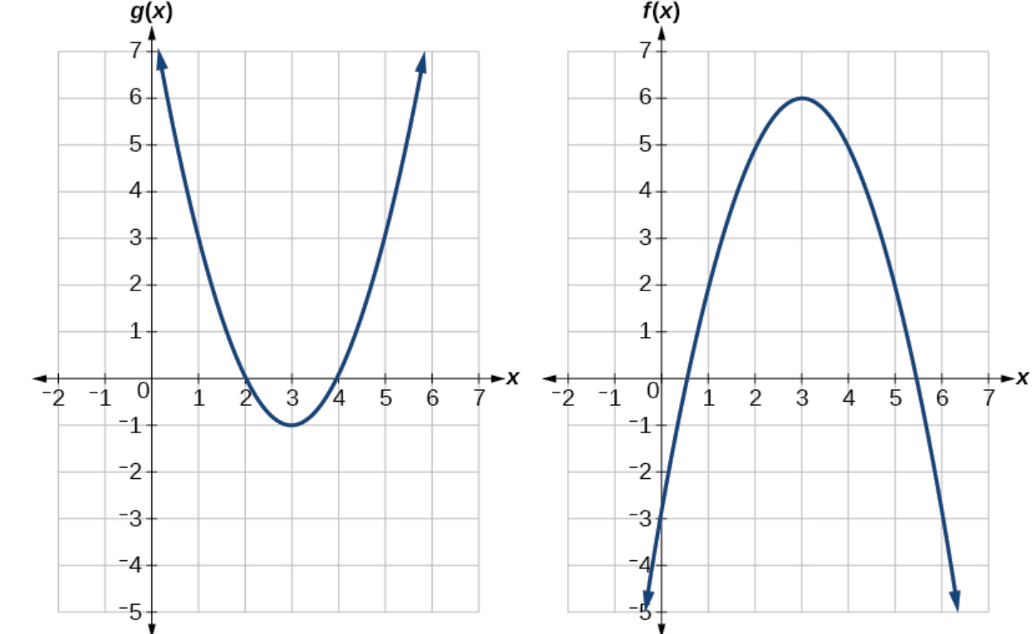
- Using the graphs below, evaluate $f\left(g\left(1\right)\right)$ and $g\left(f\left(2\right)\right)$

$f\left(g\left(1\right)\right): g\left(1\right)=3$, $f\left(3\right)=6$
$$g\left(f\left(2\right)\right): f\left(2\right)=5, g\left(5\right)=3$$

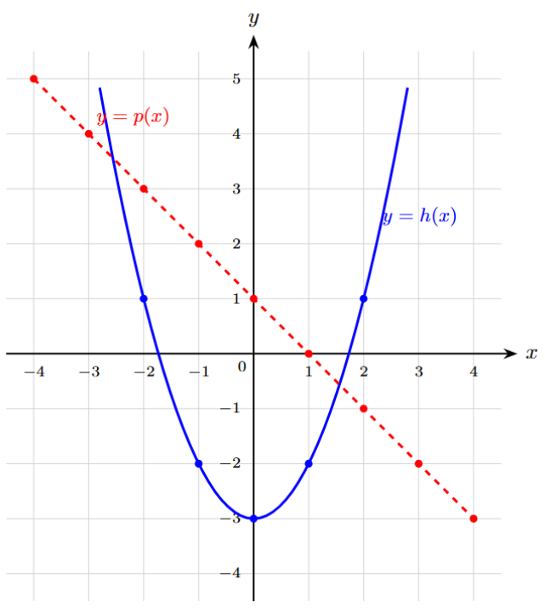
- Consider the graphs of $p\left(x\right)$ and $h\left(x\right)$ below. Evaluate:
  - $h\left(p\left(2\right)\right)$

$$-2$$
  - $p\left(h\left(2\right)\right)$

$$0$$
  - $h\left(h\left(1\right)\right)$

$$1$$
  - $p\left(p\left(-3\right)\right)$

$$-3$$

Mastery
- $f\left(x\right)=x^{2}-3$ and $g\left(x\right)=x-1$
  - Find an expression for $gf(x)$
  - Find an expression for $fg\left(x\right)$
  - Solve the equation $gf(x)=fg(x)$

$$gf\left(x\right)=x^{2}-4 \\ fg\left(x\right)=x^{2}-2x-2 \\ x^{2}-4=x^{2}-2x-2$$
$$2x=2$$
$$x=1$$
- $g(x)=x-12$ and $h(x)=x^{2}-10$
Solve the equation $gh(x)=hg(x)$

$$gh\left(x\right)=x^{2}-22$$
$$hg\left(x\right)={\left(x-12\right)}^{2}-10=x^{2}-24x+134 \\ x^{2}-22=x^{2}-24x+134 \\ 24x=156$$
$$x=6.5$$
- $f(x)=2x+k$ and $g(x)=kx+3$
$$fg(x)=10x+m$$Find the values of $k$ and $m$.

$$fg\left(x\right)=2\left(kx+3\right)+k=2kx+6+k \\ 2k=10$$
$$k=5 \\ m=6+k=11$$
- $g(x)=3x+2$ and $h(x)=6x+5$
Show that $gh(x)=hg(x)$

$$gh(x)=3(6x+5)+2=18x+17 \\ hg(x)=6(3x+2)+5=18x+17 \\ ∴gh(x)=hg(x)$$
- $g(x)=\frac{2x+1}{x-1}$ and $h(x)=\frac{x+3}{x-5}$
Find an expression for $gh(x)$

$$gh\left(x\right)=\frac{2·\frac{x+3}{x-5}+1}{\frac{x+3}{x-5}-1}$$
$$=\frac{2\left(x+3\right)+\left(x-5\right)}{\left(x+3\right)-\left(x-5\right)}$$
$$=\frac{3x+1}{8}$$
- Let $f\left(x\right)=\frac{1}{4x-1}$ and $g\left(x\right)=2^{x}$. Find the value of $k$ such that $g\left(g\left(3\right)\right)=f\left(k\right)$.
$$g\left(g\left(3\right)\right)=2^{2^{3}}=256$$
$$256=\frac{1}{4k-1}$$
$$4k-1=\frac{1}{256}$$
$$4k=\frac{257}{256}$$
$$k=\frac{257}{1024}$$
- Let $f\left(x\right)=\sqrt{x}$ and $g\left(x\right)=-x^{2}-1$. Find $g\left(f\left(x\right)\right)$ and $f\left(g\left(x\right)\right)$.
Which composite function does not exist, and why?

$$g\left(f\left(x\right)\right)=-x-1$$
$$f\left(g\left(x\right)\right)=\sqrt{-x^{2}-1}$$
Since $-x^{2}-1$ is always negative, $f\left(g\left(x\right)\right)$ is undefined.
- Given that $f(x)=4x-3$ and $f(g(x))=12x+5$, determine the algebraic formula for $g(x)$.

$$\begin{aligned}f(g(x))&=4(g(x))-3 \\ 4(g(x))-3&=12x+5 \\ 4(g(x))&=12x+8 \\ g(x)&=3x+2\end{aligned}$$
- Two linear functions are defined as $f(x)=2x+k$ and $g(x)=3x-4$, where $k$ is a real constant.
  - Find simplified algebraic expressions for $f(g(x))$ and $g(f(x))$.

$$\begin{aligned}f(g(x))&=2(3x-4)+k=6x-8+k \\ g(f(x))&=3(2x+k)-4=6x+3k-4\end{aligned}$$
  - Determine the unique value of $k$ for which $f(g(x))=g(f(x))$ for all values of $x$.

For $f(g(x))=g(f(x))$ to hold identically for all $x$:
$$\begin{aligned}6x-8+k&=6x+3k-4 \\ -8+k&=3k-4 \\ -4&=2k \\ k&=-2\end{aligned}$$

- Let $g\left(x\right)$ be an even function and $f\left(x\right)$ be any function. Let $h\left(x\right)=f\left(g\left(x\right)\right)$.
  - Explain why $h\left(-x\right)=f\left(g\left(x\right)\right)$.

$$h\left(-x\right)=f\left(g\left(-x\right)\right)$$
since $g\left(x\right)$ is even, then $g\left(-x\right)=g\left(x\right)$
$$∴h\left(-x\right)=f\left(g\left(x\right)\right)$$
  - Hence explain why the function $h\left(x\right)$ is even.

Since $h\left(-x\right)=f\left(g\left(x\right)\right)=h\left(x\right)$, it is even.
  - Therefore, what can you say about the composition of two functions if the “inside” function is even?

It is even.
  - Similarly, show that if $f\left(x\right)$ is even and $g\left(x\right)$ is odd, then $h\left(x\right)=f\left(g\left(x\right)\right)$ is even.

$$h\left(-x\right)=f\left(g\left(-x\right)\right)$$
since $g\left(x\right)$ is odd, then $g\left(-x\right)=-g\left(x\right)$
$$h\left(-x\right)=f\left(-g\left(x\right)\right)$$
since $f\left(x\right)$ is even, $f\left(-x\right)=f\left(x\right)$
$$∴h\left(-x\right)=f\left(g\left(x\right)\right)=h\left(x\right)$$
  - Similarly, show that if $f\left(x\right)$ and $g\left(x\right)$ are both odd, then $h\left(x\right)=f\left(g\left(x\right)\right)$ is odd.

$$h\left(-x\right)=f\left(g\left(-x\right)\right)$$
since $g\left(x\right)$ is odd, then $g\left(-x\right)=-g\left(x\right)$
$$h\left(-x\right)=f\left(-g\left(x\right)\right)$$
since $f\left(x\right)$ is also odd, $f\left(-x\right)=-f\left(x\right)$
$$∴h\left(-x\right)=-f\left(g\left(x\right)\right)=-h\left(x\right)$$

- 2022 HSC Advanced Band 5
The graphs of $y=f\left(x\right)$ and $y=g\left(x\right)$ are shown.
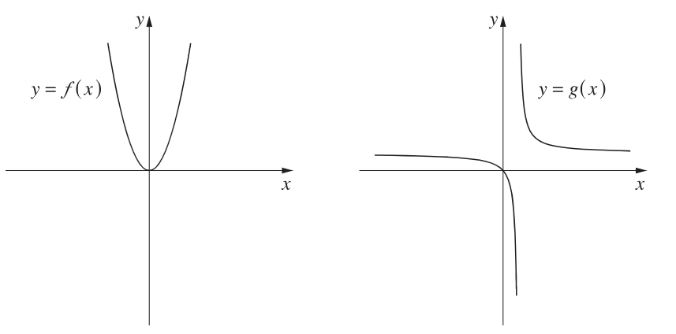

Which graph best represents $y=g\left(f\left(x\right)\right)$?
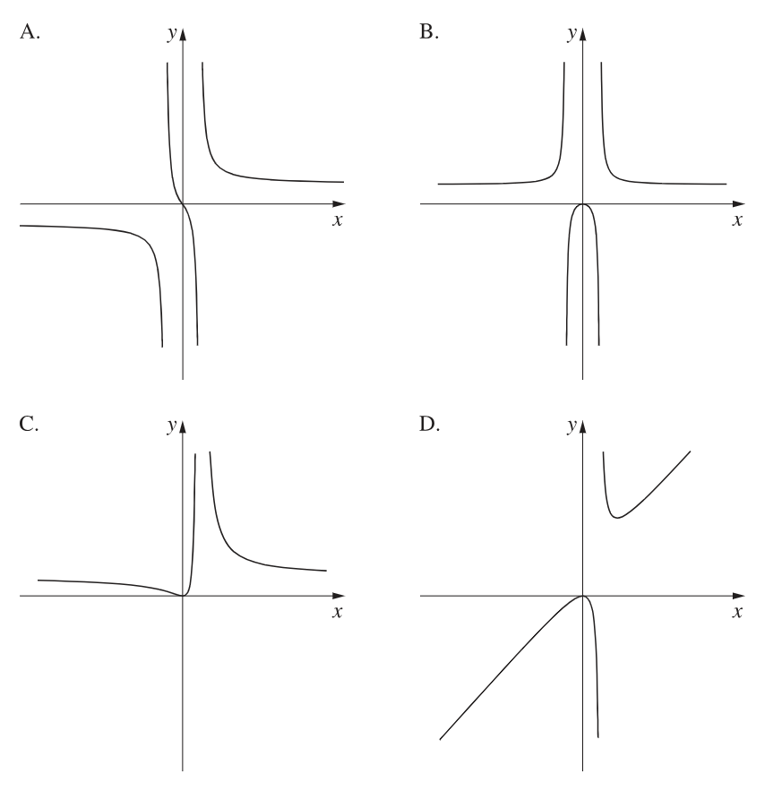

Since $f\left(x\right)$ is even, $g\left(f\left(x\right)\right)$ will also be even.
B
- Consider once again the graph of $f\left(x\right)$ and $g\left(x\right)$ below.
  - Find all values of $x$ in the domain $\left[-4,5\right]$ that satisfy $f(g(x))=3$.

Consider $f\left(g(x)\right)=3$
$$\text{Look for points where graph }f\text{ reaches height }y=3.$$
$$\text{From the grid, }f\left(g\left(x\right)\right)=3\text{ only when }g\left(x\right)=0.$$
Solve $g\left(x\right)=0:$
$$x=-1, 5$$
  - [2-cycle fixed points]
    - Evaluate $ffff\left(x\right)$ for $x=0$.
    - Evaluate $ffff\left(x\right)$ for $x=3$.
    - Explain geometrically why the pair $\{0,3\}$ forms an alternating cycle under composition by $f$, and state other alternating cycles for $f$.

Repeated compositions of $x=0$ and $x=3$ keep alternating between $0$ and $3$.
An alternating cycle occurs when $f\left(a\right)=b$ and $f\left(b\right)=a$
Geometrically, this means $\left(a,b\right)$ and $\left(b,a\right)$ must lie on the graph of $y=f\left(x\right)$
These two points are mirror reflections across the line $y=x$
Therefore, all points with symmetry across $y=x$ on the graph of $f\left(x\right)$ will have this property, such as $\left\{1,2\right\}$ and $\left\{0.5,2.5\right\}$
By considering the graph, the solution set is all $\left(x,y\right)$ pairs satisfying $y=3-x$ in the domain $x∈\left[0,3\right]$

Domain and Range of Composite Functions

- Domain and Range of Composite Functions
To find the domain of $f\left(g\left(x\right)\right):$
- Write the equation of $f\left(g\left(x\right)\right)$.
- Determine the natural domain using zero denominators being undefined and square roots must be non-negative.

- Example Determine domain and range of a composite function
$$f\left(x\right)=\frac{1}{x}$$
$$g\left(x\right)=\sqrt{x-4}$$
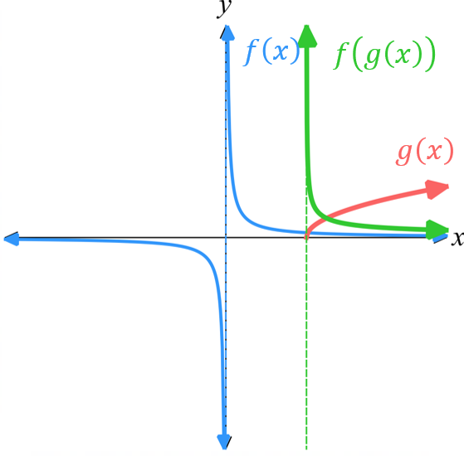
Find the domain of $f\left(g\left(x\right)\right)$.
$$f\left(g\left(x\right)\right)=\frac{1}{\sqrt{x-4}}$$
$$x-4>0$$
$x>4$

Find the range of $f\left(g\left(x\right)\right)$.
Since $\sqrt{x-4}$ $>0$, then $\frac{1}{\sqrt{x-4}}$ $>0$
$∴$ $f\left(g\left(x\right)\right)>0$

- Guided Practice
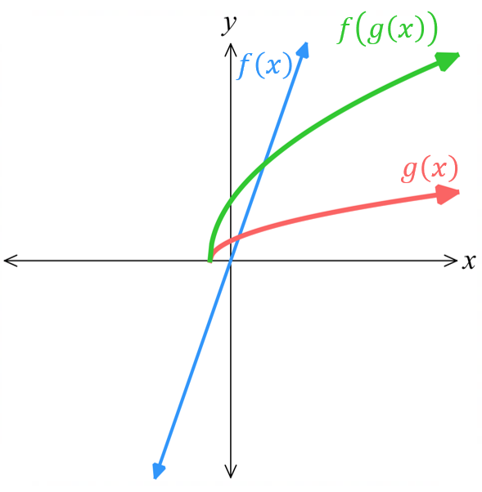
$$f\left(x\right)=3x$$
$$g\left(x\right)=\sqrt{x+1}$$

Find $f\left(g\left(x\right)\right)$.

$$3\sqrt{x+1}$$
Hence find the domain of $f\left(g\left(x\right)\right)$.

$$x≥-1$$
Hence find the range of $f\left(g\left(x\right)\right)$.

$$f\left(g\left(x\right)\right)≥0$$

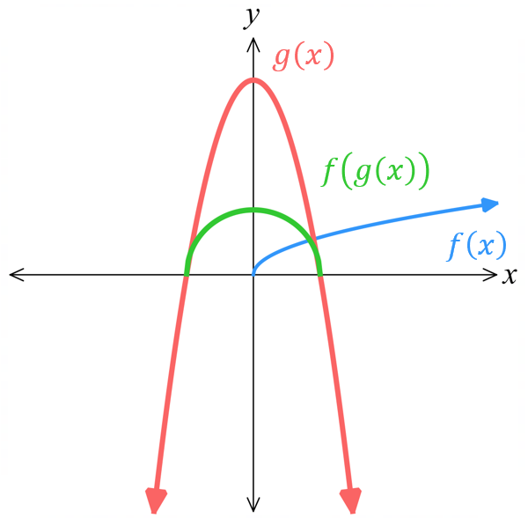
$$f\left(x\right)=\sqrt{x}$$
$g\left(x\right)=$ $9-x^{2}$

Find $f\left(g\left(x\right)\right)$.

$$\sqrt{9-x^{2}}$$
Hence find the domain of $f\left(g\left(x\right)\right)$.

$$-3≤x<3$$
Hence find the range of $f\left(g\left(x\right)\right)$.

$$0≤f\left(g\left(x\right)\right)≤3$$
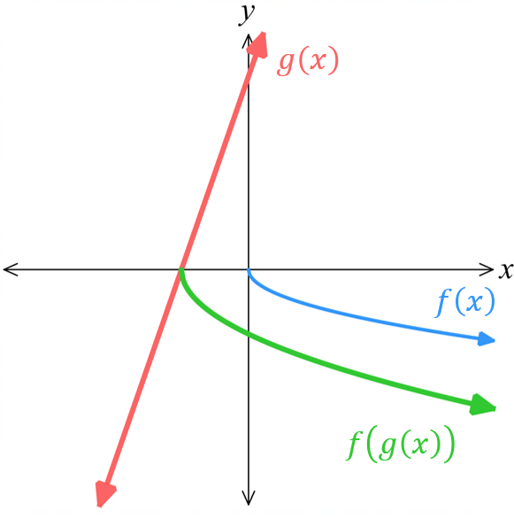
$$f\left(x\right)=-\sqrt{x}$$
$g\left(x\right)=$ $3x+9$

Find $f\left(g\left(x\right)\right)$.

$$-\sqrt{3x+9}$$
Hence find the domain of $f\left(g\left(x\right)\right)$.

$$x≤-3$$
Hence find the range of $f\left(g\left(x\right)\right)$.

$$f\left(g\left(x\right)\right)≤0$$

Development
- Write the composite function $f\left(g\left(x\right)\right)$ and state its domain and range.
- $f\left(x\right)=x^{2}$ and $g\left(x\right)=x-1$  $$y=x^{2}-2x+1$$  D: $\left(-∞,∞\right)$  R: $\left[0,∞\right)$ | - $f\left(x\right)=x^{3}$ and $g\left(x\right)=x+5$  $$y={\left(x+5\right)}^{3}$$  D: $\left(-∞,∞\right)$  R: $\left(-∞,∞\right)$
- $f\left(x\right)=\sqrt{x}$ and $g\left(x\right)=x-2$  $$y=\sqrt{x-2}$$  D: $\left[2,∞ \right)$  R: $\left[0,∞\right)$ | - $f\left(x\right)=-\sqrt{x}$ and $g\left(x\right)=3x+9$  $$y=-\sqrt{3x+9}$$  D: $\left[-3,∞ \right)$  R: $\left(-∞,0\right]$
- $f\left(x\right)=\sqrt{x}$ and $g\left(x\right)=4-x^{2}$  $$\sqrt{4-x^{2}}$$  D: $\left[-2,2\right]$  R: $\left[0,2\right]$ | - $f\left(x\right)=-\sqrt{x}$ and $g\left(x\right)=1-x^{2}$  $$-\sqrt{1-x^{2}}$$  D: $\left[-1,1\right]$  R: $\left[-1,0\right]$

- $f\left(x\right)=$ $\frac{2}{x-9}$ and $g\left(x\right)=x^{2}$.
  - Find $f\left(g\left(x\right)\right)$

$$\frac{2}{x^{2}-9}$$
  - Find $g\left(f\left(x\right)\right)$

$$\frac{4}{{\left(x-9\right)}^{2}}$$
  - Compare the domain of $f\left(g\left(x\right)\right)$ and $g\left(f\left(x\right)\right)$.

$f\left(g\left(x\right)\right)$ has domain $x∈R, x≠±3$ while $g\left(f\left(x\right)\right)$ has domain $x∈R, x≠9$

- $f\left(x\right)=x-2$ and $g\left(x\right)=\sqrt{x}$
  - Find $f\left(g\left(x\right)\right)$.

$$\sqrt{x}-2$$
  - Hence state the domain of $f\left(g\left(x\right)\right)$.

$$x≥0$$
  - Find the domain of $g\left(f\left(x\right)\right)$.

$$x≥2$$

- $f\left(x\right)=2x-3, g\left(x\right)=\sqrt{x}, h\left(x\right)=x^{2}+1$
Simplify these expressions, hence state the domain.
- $f\left(g\left(x\right)\right)$  $$2\sqrt{x}-3, x≥0$$ | - $g\left(f\left(x\right)\right)$  $$\sqrt{2x-3}, x≥\frac{3}{2}$$
- $h\left(f\left(x\right)\right)$  $$4x^{2}-12x+10, x∈R$$ | - $g\left(h\left(x\right)\right)$  $$\sqrt{x^{2}+1}, x∈R$$

- If $f\left(x\right)=x^{2}-3$ and $g\left(x\right)=\sqrt{x-2}$, find $f\left(g\left(x\right)\right)$ and its domain.

$$f\left(g\left(x\right)\right)={\left(\sqrt{x-2}\right)}^{2}-3=x-5$$
Since the domain of $g\left(x\right)$ is restricted to $x≥2$, the domain of $f\left(g\left(x\right)\right)$ is also restricted to $x≥2$

- If $f\left(x\right)=\sqrt{x}$ and $g\left(x\right)=25-x^{2}$, find $f\left(g\left(x\right)\right)$ and its domain.

$$f\left(g\left(x\right)\right)=\sqrt{25-x^{2}}$$
D: $-5≤x≤5$
R: $0≤y≤5$
- Given $f\left(x\right)=\sqrt{x^{2}-9}$ and $g\left(x\right)=x+5$
  - Find integers $c$ and $d$ such that $f\left(g\left(x\right)\right)=\sqrt{\left(x+c\right)\left(x+d\right)}$

$$f\left(g\left(x\right)\right)=\sqrt{{\left(x+5\right)}^{2}-9}$$
$$=\sqrt{x^{2}+10x+16}$$
$$=\sqrt{\left(x+2\right)\left(x+8\right)}$$
$c=2, d=8$(or other way around)
  - Hence state the domain for which $f\left(g\left(x\right)\right)$ is defined.

$$\left(x+2\right)\left(x+8\right)≥0$$
$$∴x≤-8,x≥2$$

